TITLE : Anaesthetic Management of case of Total Splenectomy in a child with B thalassemia

Authors : Dr Arpita Kakoti

Email : kakotiarpita1996@gmail.com

Mobile : 8876534161

Keywords : Splenectomy, B thalassemia

Introduction : Beta thalassemia is a genetic disorder characterised by reduced or absent synthesis of B chains of Haemoglobin leading to chronic anaemia. Splenectomy is carried out in patients with hypersplenism.

Case Report : A 5 year old ,male , who is a diagnosed case of HbE disease with beta thalassemia, presented with splenomegaly. Patient had history of multiple blood transfusions. Patient was premedicated and the induced with injection propofol. Muscle Relaxant used was injection Atracurium. Patient was then intubated using direct laryngoscopic vision and then anaesthesia was maintained with oxygen: air titrated with sevofluorane. At the end of surgery , patient was then reversed with neostigmine and glycopyrrolate. Post operative vitals of the patient was stable and patient was discharged after one week.

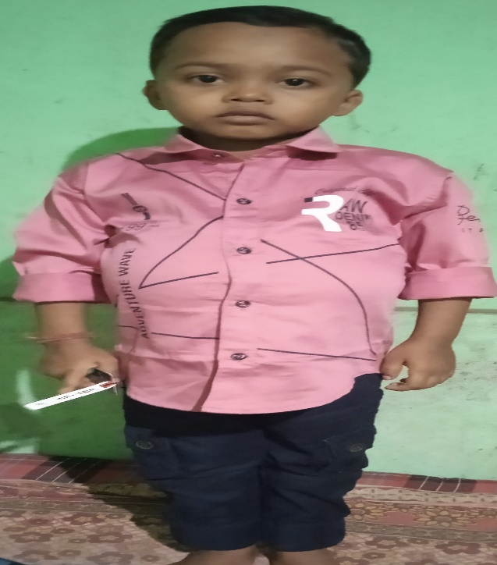

Conclusion : Beta thalassemia may lead to chronic anemia , extramedullary haematopoesis , splenomegaly, bone deformities. Management consist of blood trasfusions at regular intervals and splenectomy if splenomegaly present. During anesthesia , utmost care should be given to manage the cardiac output and any factors affecting SVR OR PVR should be avoided.

References

* Jameson et al, Harrison’s Principles of Internal medicine, 20th edition, 2018.
* Jyothi B et al, Anesthetic management of beta thalassemia major with hypersplenism for splenectomy in pediatric age group : Report of four cases. Anesth Essays Res. 2015 May-Aug;9(2):266-9.